Wave Interference
W. Interference: occurs when 2 or more waves interact (collide)
Interference can be constructive or destructive.
Constructive interference: occurs when 2 or more waves interact and cause an increase in amplitude, velocity or both.
Example: 2 waves traveling in the same direction.
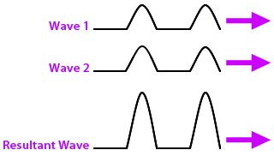

Destructive interference: occurs when 2 or more waves interact and cause a decrease in amplitude, velocity or both.
Example: waves traveling in opposite directions.
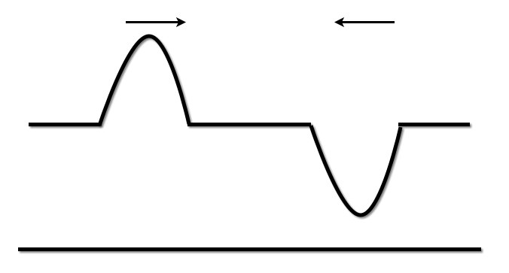
**The flat line represents the waves “canceling each other out”.

