Unit 5 Problems I.
- If the angle of incidence of a light ray was 5 degrees and the angle of refraction was 2.5 degrees, what is the index of refraction?

- If the angle of incidence of a light ray was 35 degrees and the angle of refraction was 25 degrees, what is the index of refraction?

- If the angle of refraction of light traveling through Carbon Dioxide was 20 degrees, what is the angle of incidence (use given table)?

- If the angle of refraction of light traveling through Quartz was 10 degrees, what is the angle of incidence (use given table)?

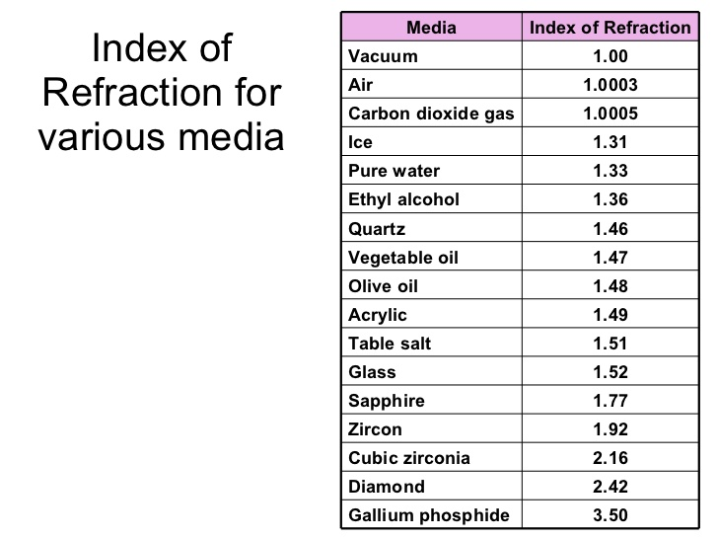
- If a lens created an image .15 m behind a lens and the object was .08 m in front of the lens, what is the focal point?
- If a wave had a frequency of 15 Hz, what is the period?
- If a lens had a focal point of .13 m, an object distance of .15 m in front of the lens, what is the image distance?
- If 25 waves past in 14.5 s, what is the frequency?
- Use the law of Cosine and the Law of sine to calculate:
30 N @ 15 degrees + 40 N @ 50 degrees, Resultant?

