Unit 5 Problems II
- If the angle of incidence of a light ray was 43 degrees and the angle of refraction was 32 degrees, what is the index of refraction?

- If the angle of incidence of a light ray was 5 degrees and the angle of refraction was 10 degrees, what is the index of refraction?

- If the angle of refraction of light traveling through Carbon Dioxide was 30 degrees, what is the angle of incidence (use given table)?

- If the angle of refraction of light traveling through Quartz was 25.2369 degrees, what is the angle of incidence (use given table)?

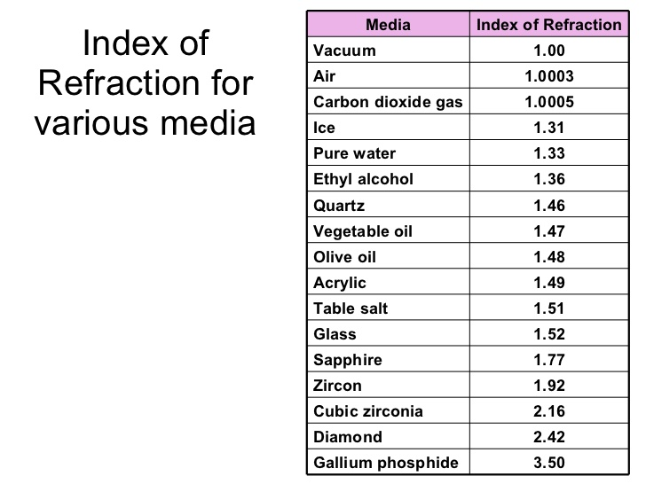
- If a lens created an image .13 m behind a lens and the object was .0008 m in front of the lens, what is the focal point?
- If a wave had a frequency of 49 Hz, what is the period?
- If a lens had a focal point of .41 m, an object distance of .40 m in front of the lens, what is the image distance?
- If 32 waves past in 43 s, what is the frequency?
- Use the law of Cosine and the Law of sine to calculate:
5.5 N @ 55 degrees + 4.5 N @ 45 degrees, Resultant?

