Top 10 Inventions Article

The CNN 10: Inventions
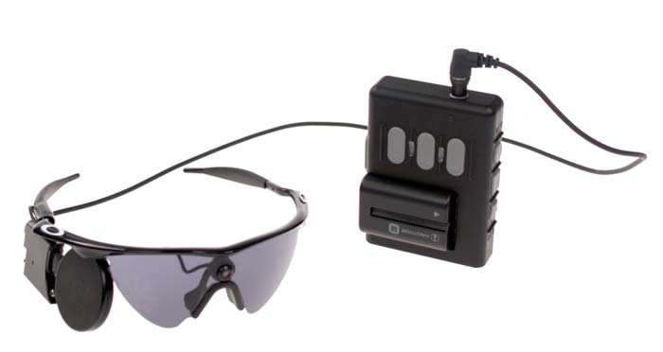
From Second Sight

Argus II Retinal Prosthesis System
1 of 10
WHO MAKES IT?
Second Sight Medical Products; Sylmar, California
WHAT DOES IT DO?
It’s a “bionic retina” for people suffering from retinitis pigmentosa
IS IT ON THE MARKET?
Yes, in select medical centers
WHY IT’S COOL
It gives sight to the visually impaired
By Todd Leopold, CNN
In the old TV show “The Six Million Dollar Man,” astronaut Steve Austin was given bionic body parts after a horrific crash. Austin gets a new right arm, two replacement legs and a left eye with a zoom lens and night-vision capacities.
The Argus II Retinal Prosthesis System isn’t quite that advanced. But for the vision-impaired, the “bionic retina” is a huge leap forward.
The device, which was created by the California-based company Second Sight Medical Products, has been available in Europe since 2011. It received U.S. approval in February – the first visual prosthesis to do so. Second Sight CEO Robert Greenberg has devoted more than 20 years of his life to the invention.
The Argus II functions as an artificial retina, the light-sensitive part of the eye that collects image information and passes it along to the brain through the optic nerve. (It’s often considered similar to the film in a camera.) People with a disease called retinitis pigmentosa (RP) – about 100,000 Americans -- lose the retina’s light-sensitive cells. It’s here that the Argus II takes over.
The device is surgically implanted in and on the eye, according to the Argus II website. It contains an antenna and some electronics, and connects to an exterior system consisting of eyeglasses, a video processing unit (VPU) and a connecting cable. The glasses contain a camera that sends image information through the VPU and to the implant.
The end result is some vision restoration. "The device may help adults with RP who have lost the ability to perceive shapes and movement to be more mobile and to perform day-to-day activities," the FDA’s Dr. Jeffrey Shuren said in a news release.
The Argus II is available for adults 25 and over. It’s currently available at a handful of American eye centers. Though it’s expensive – about $144,000 – Medicare announced it would cover the costs, and other insurers are expected to follow.
And it’s just the beginning, Greenberg told the trade publication Medical Device and Diagnostic Industry.
“It's a computer-based system, so you can imagine in 10 years how much cell phone and computer technology has advanced,” Greenberg adds.
Expect much more light to shine in the future.

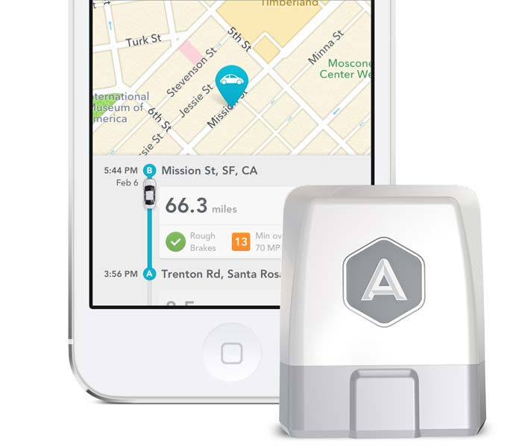
From Automatic Labs

Automatic
3 of 10
WHO MAKES IT?
Automatic Labs; San Francisco, California
WHAT DOES IT DO?
Wirelessly syncs data from your car to your smartphone
IS IT ON THE MARKET?
Yes, for $100
WHY IT’S COOL:
It turns regular cars into smart cars
By Heather Kelly, CNN
In the future we will have self-driving cars that weave in and out of traffic and coordinate silently with other vehicles on the road, all while we sit back with a latte, reading a book.
That future is still a ways off, and even when those cars arrive they will be expensive. But Automatic brings a bit of the smart-car future to our existing vehicles with a small device that attaches to a car's onboard computer via a port under the steering wheel.
It works with most gas-powered cars from 1996 or later. The hardware syncs with an iPhone app over Bluetooth. (There's an Android app coming in December.)
Automatic pulls data about your engine and driving habits and displays the results on your phone so you can save energy and money. It maps out each trip using GPS, tallies gas usage and mileage, and gives you a driving score. When your car flashes the dreaded "check engine" light, it deciphers the code and tells you exactly what the problem is. It even remembers where you parked.
Together, these small steps can add up to a positive environmental impact. When you're burning up fuel unnecessarily by speeding, accelerating too quickly or slamming on the brakes, the app will make a sound.
Automatic also can detect when you're in a car accident. If your smartphone is on, has a GPS signal and is still working, it will automatically contact local authorities and your family members.

From MakerBot

MakerBot Digitizer
5 of 10
WHO MAKES IT?
MakerBot Industries; Brooklyn, New York
WHAT DOES IT DO?
Scans 3D objects so that they can be printed
IS IT ON THE MARKET?
Yes, as of October. Prices start at $1,400
WHY IT’S COOL:
It helps you clone small objects
By Brandon Griggs, CNN
Printing of three-dimensional objects has been a hot trend in the tech world for the last several years, but an obstacle has kept the process from going mainstream: To print anything, you first need a computer-created digital model that tells the printer what to make. Models are available online for thousands of common objects, but if you wanted to print a rare or custom-made item you had to somehow model it on your own. Where did you start?
Enter the MakerBot Digitizer, a desktop device that scans almost any small object up to about 8 inches in diameter. Place the item on its rotating turntable, and the Digitizer uses two lasers and a webcam to create a 3-D digital file of it within 12 minutes. Anyone can do it -- no special expertise is required. Once the digital scan is completed, an object can be manufactured right away by feeding the resulting file to a 3-D printer. It’s much easier and faster than using software to design a digital model from scratch.
Let’s say, for example, you lose a knight piece from your favorite chess set. You can simply scan the other knight and print a replica that will be identical in size and shape, if not color or weight. More significantly, astronauts aboard the International Space Station could scan and print replacement parts for broken or lost equipment instead of having to wait weeks for them to be delivered.
The device, meant to be paired with a MakerBot desktop 3-D printer, is still somewhat imprecise – it’s geared more for designers and hobbyists than engineers. But it’s a first step towards a new industrial revolution in which average people can become manufacturers.
“It’s a powerful tool that’s going to give you a whole new way of looking at things,” says MakerBot founder Bre Pettis, who encourages users to “blaze a trail into the future.”

From Google

Google Glass
6 of 10
WHO MAKES IT?
Google, of course
WHAT DOES IT DO?
It’s a computer you wear like glasses
IS IT ON THE MARKET?
Not yet, though it’s been available for developers and “Explorers”
WHY IT’S COOL
Smartphones are so 2012
By Todd Leopold, CNN
People see what they want to see with Google Glass.
For some, the wearable computer is the next step up from the smartphone. It’s a real-time GPS, a videocamera, an Internet browser – and it does it all while perched on the bridge of your nose like eyeglasses. Just say “OK, Glass” or gesture with your hands, and Google Glass responds instantly, showing the results in a small display that floats just above your right eye.
It’s been a source of amusement for people like author Gary Shteyngart, one of the first people in New York to try Glass, who wrote a humorous essayabout reactions as he wore it around the city. It’s also been a source of concern: Authorities consider it a driving distraction and even people who are impressed by the technology wonder if it’s just Big Brother in colorful frames.
So far, Google has offered Glass only through its Explorer program, which requires a compelling reason and $1,500 for a tester model. But a mass-produced version is expected to hit the market in 2014.
Its capabilities are immense: integration with medical technology, on-the-spot journalism, “augmented reality,” hands-free photography, even exchanging virtual lives. (But no sex, please – at least not unless you want to get Google mad.)
Google hasn’t given a specific date Glass will go on sale. In fact, it hasn’t acknowledged if Glass will sell widely at all. But there’s a boat floating in San Francisco Bay that may offer some clues to the future. According to speculation, it’s soon to be a Glass showroom.
Want to see Glass? Your ship may come in very soon.

