Thermodynamics and
Spontaneous Processes.
Thermodynamics: the area of science that deals with the interconversion (energy converting back and forth) of heat and other forms of energy.
Spontaneous Process: is one that proceeds on its own without external influence.
The reverse of a spontaneous process is always nonspontaneous and takes place only in the presence of some external influence.
Example:
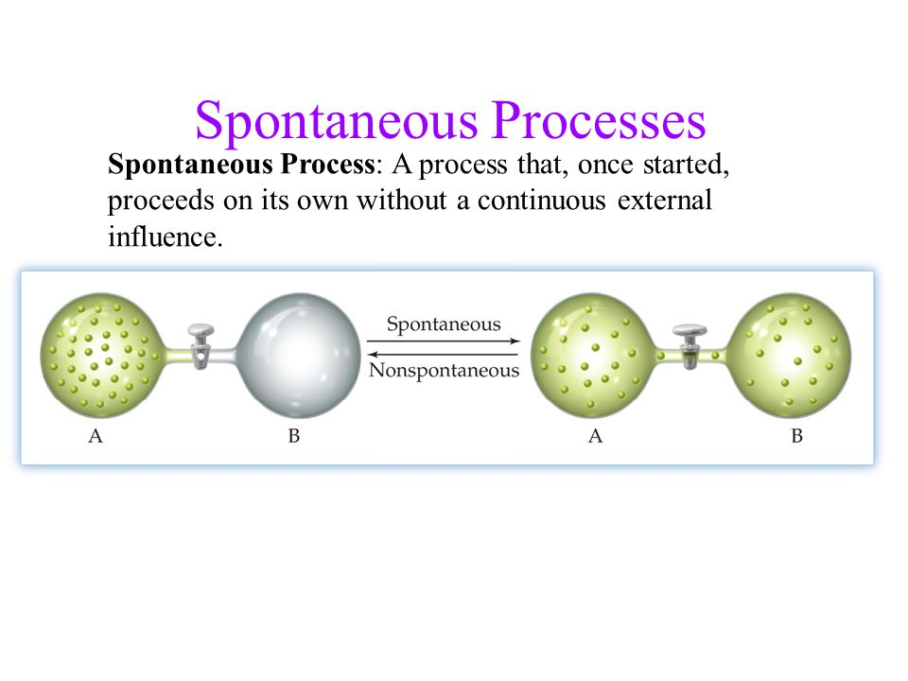
Once the valve is open, the gas in bulb “A” spontaneously expands into bulb “B” to fill the available volume.
The reverse process would be non – spontaneous because it would require an outside influence (like a piston).
Chemical reactions can also be labeled as spontaneous or non – spontaneous.
Example: Combining hydrogen gas with oxygen gas in the presence of a platinum catalyst. Platinum catalyst
2H₂ (g) + O₂(g) 2 H₂O (l)
The forward reaction happens spontaneously, but the reverse reaction (decomposition of water) requires electricity (outside influence) and will not occur no matter you long you wait.
In general, whether the forward or reverse is spontaneous, depends on the temperature, pressure and composition (what it’s made of) of the reaction mixture.

