Standing Waves, Natural Frequencies and Resonance.
**Remember that waves are a disturbance through some kind of medium (material the wave travels through).
Depending on the medium and the energy (amplitude) of the wave, if a “standing wave” is produced waves can create a “natural frequency” which will create a “resonance” or a transferred wave.
Standing waves: Waves that vibrate in 1 place and are not traveling anywhere.
Example: a rope tied to a tree:
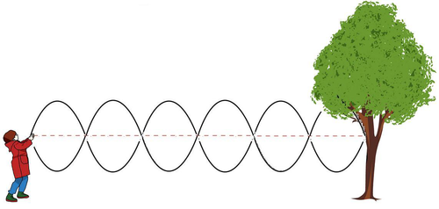
**As the person moves the rope up and down the rope does not leave the distance from the person to the tree.
Natural Frequency: is a specific frequency when a wave creates a standing wave.
Example: When the tuning fork transferred its vibration to the plastic tube during the resonance Lab.
Resonance: occurs when a wave reaches it’s natural frequency, creating a standing wave and vibrates (osscilates) back and forth without traveling anywhere.
Example: When wind instrument (trumpet) reaches a specific note.

