Predicting the Direction of Acid – Base Reactions.
If you mix equal concentrations of reactants and products, the direction of the reaction can be identified by:
- Identifying the acids and the bases.
- Using a given table of relative strengths of acids and bases.
Example A.)
H₂SO₄ (aq) + NH₃ (aq) NH₄⁺(aq) + HSO₄⁻(aq)
When equal concentrations of reactants and products are present, proton transfer always occurs from the stronger acid to the stronger base.
In reaction A.), H₂SO₄ and NH₄⁺ are the acids and NH₃ and HSO₄⁻ are the bases.

According to table 15.1, H₂SO₄ is a stronger acid than NH4+ and NH3 is a stronger base than HSO₄⁻.
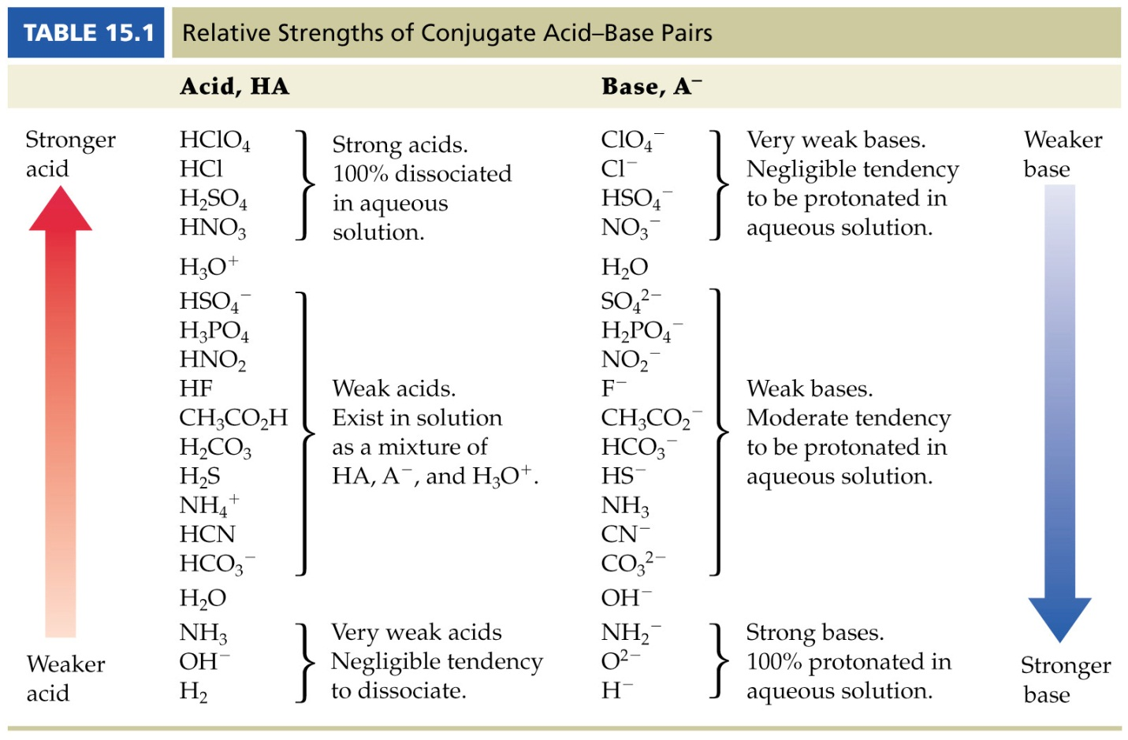
Therefore, NH₃ gets the proton and the reaction proceeds from left to right.
H₂SO₄ (aq) + NH₃ (aq) NH₄ ⁺(aq) +HSO4 (aq)⁻
Stronger acid Stronger base Weaker acid Weaker base

