Phase of matter

Learning Target:

The students will learn what the phases of matter are, the changes they go through, how energy is involved and how to collect and graph data while matter is going through a phase change.

There are 4 phases of matter: solid, liquid, gas and plasma.

Each Phase of matter has a different amount of energy.

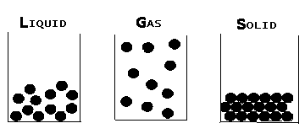

Energy: Medium High Low

Plasma: has the highest energy of the 4 phases.

Phase Changes: occur when ever a substance either gains enough energy or loses enough energy to change state.

**Examples:**

**Freezing: Liquid to solid.**

**Evaporation: Liquid to gas. Condensation: Gas to liquid.**

**Melting: Solid to liquid.**

**Sublimation: Solid to gas (dry ice).**

**All phase changes are physical changes.**