Performance Enhancing Drug Article

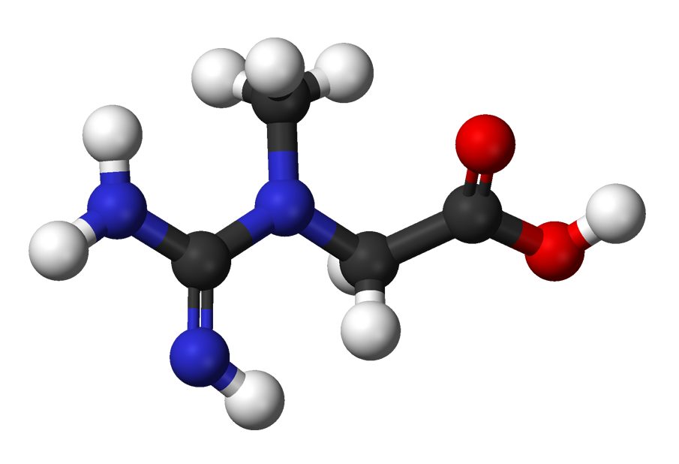

Creatine (C₄H₉N₃O₂)

Medications and Drugs

What is creatine ()?
The use of creatine in cultural and traditional settings may differ from concepts accepted by current Western medicine. When considering the use of herbal/health supplements, consultation with a primary health care professional is advisable. Additionally, consultation with a practitioner trained in the uses of herbal/health supplements may be beneficial, and coordination of treatment among all health care providers involved may be advantageous.
Creatine is produced naturally in the kidney, liver, and pancreas of humans. Creatine is also supplied in meat and fish. Most creatine in the body is stored in the muscles, in the form of phosphocreatine. Creatine is a quickly available source of energy for muscle contraction. Creatine is also involved in muscle growth.
Creatine has been used to enhance athletic performance.
Creatine has not been evaluated by the FDA for safety, effectiveness, or purity. All potential risks and/or advantages of creatine may not be known. Additionally, there are no regulated manufacturing standards in place for these compounds. There have been instances where herbal/health supplements have been sold which were contaminated with toxic metals or other drugs. Herbal/health supplements should be purchased from a reliable source to minimize the risk of contamination.
Creatine may also have uses other than those listed in this product guide.

What are the possible side effects of creatine ()?
Although uncommon, serious side effects have been reported with the use of creatine. Stop taking creatine and seek emergency medical attention or notify your doctor immediately if you experience:
- an allergic reaction (difficulty breathing; closing of your throat; swelling of your lips, tongue, or face; or hives); or
- symptoms of kidney problems such as decreased or little urine.
This is not a complete list of side effects and others may occur. Call your doctor for medical advice about side effects. You may report side effects to FDA at 1-800-FDA-1088.

What is the most important information I should know about creatine ()?
Drink plenty of fluid while taking creatine. Although it has not been proven, dehydration, heat-related illnesses, muscle cramps, reduced blood volume, and electrolyte imbalances are expected to be more likely to occur while taking creatine.
Creatine has not been evaluated by the FDA for safety, effectiveness, or purity. All potential risks and/or advantages of creatine may not be known. Additionally, there are no regulated manufacturing standards in place for these compounds. There have been instances where herbal/health supplements have been sold which were contaminated with toxic metals or other drugs. Herbal/health supplements should be purchased from a reliable source to minimize the risk of contamination.

Who should not take creatine ()?
Before taking creatine, talk to your doctor, pharmacist, or health care professional if you have any other medical conditions, allergies, or if you take other medicines or other herbal/health supplements. Creatine may not be recommended in some situations.
There is no information available regarding the use of creatine by children. Do not give any herbal/health supplement to a child without first talking to the child's doctor.

How should I take creatine ()?
The use of creatine in cultural and traditional settings may differ from concepts accepted by current Western medicine. When considering the use of herbal/health supplements, consultation with a primary health care professional is advisable. Additionally, consultation with a practitioner trained in the uses of herbal/health supplements may be beneficial, and coordination of treatment among all health care providers involved may be advantageous.
If you choose to take creatine, use it as directed on the package or as directed by your doctor, pharmacist, or other health care provider.
One method of supplementing with creatine is called the "loading method". This consists of taking larger doses of creatine for 3 to 4 days. This method has been used by athletes when a short term rise in force is needed, such as before a football game or a weight lifting competition. Another method supplementing with creatine has been to use smaller doses over an extended training period. This method has been used by athletes who are more endurance focused or for long term training such as body building.
Different formulations of creatine may be available to be used internally (orally). Do not use different formulations (e.g., tablets, liquid, and powder) of creatine at the same time, unless specifically directed to do so by a health care professional. Using different formulations together increases the risk of an overdose of creatine.
It has been reported that creatine may be more effective if taken with carbohydrates.
Drink plenty of fluid while taking creatine. Although it has not been proven, dehydration, heat-related illnesses, muscle cramps, reduced blood volume, and electrolyte imbalances are expected to be more likely to occur while taking creatine.
Store creatine as directed on the package. In general, creatine should be protected from light and moisture and stored in a sealed container.
Next Page:

Performance-enhancing drugs: Know the risks

Are you hoping to gain a competitive edge by taking muscle-building supplements or other performance-enhancing drugs? Learn how these drugs work and how they can affect your health.
By Mayo Clinic staff
Most serious athletes will tell you that the competitive drive to win can be fierce. Besides the satisfaction of personal accomplishment, athletes often pursue dreams of winning a medal for their country or securing a spot on a professional team. In such an environment, the use of performance-enhancing drugs has become increasingly common.
But using performance-enhancing drugs — aka, doping — isn't without risks. Take the time to learn about the potential benefits, the health risks and the many unknowns regarding so-called performance-enhancing drugs such as anabolic steroids, androstenedione, human growth hormone, erythropoietin, diuretics, creatine and stimulants. You may decide that the benefits aren't worth the risks.

Anabolic steroids
What are they?
Some athletes take a form of steroids — known as anabolic-androgen steroids or just anabolic steroids — to increase their muscle mass and strength. The main anabolic steroid hormone produced by your body is testosterone.
Testosterone has two main effects on your body:
- Anabolic effects promote muscle building.
- Androgenic effects are responsible for male traits, such as facial hair and a deeper voice.
Some athletes take straight testosterone to boost their performance. Frequently, the anabolic steroids that athletes use are synthetic modifications of testosterone. These hormones have approved medical uses, though improving athletic performance is not one of them. They can be taken as pills, injections or topical treatments.
Why are these drugs so appealing to athletes? Besides making muscles bigger, anabolic steroids may help athletes recover from a hard workout more quickly by reducing the muscle damage that occurs during the session. This enables athletes to work out harder and more frequently without overtraining. In addition, some athletes may like the aggressive feelings they get when they take the drugs.
Designer steroids
A particularly dangerous class of anabolic steroids are the so-called designer drugs — synthetic steroids that have been illicitly created to be undetectable by current drug tests. They are made specifically for athletes and have no approved medical use. Because of this, they haven't been tested or approved by the Food and Drug Administration (FDA) and represent a particular health threat to athletes.
Risks
Many athletes take anabolic steroids at doses that are much higher than those prescribed for medical reasons, and most of what is known about the drugs' effects on athletes comes from observing users. It is impossible for researchers to design studies that would accurately test the effects of large doses of steroids on athletes, because giving participants such high doses would be unethical. This means that the effects of taking anabolic steroids at very high doses haven't been well studied.
Anabolic steroids come with serious physical side effects as well.
Men may develop:
- Prominent breasts
- Baldness
- Shrunken testicles
- Infertility
- Impotence
Women may develop:
- A deeper voice
- An enlarged clitoris
- Increased body hair
- Baldness
- Infrequent or absent periods
Both men and women might experience:
- Severe acne
- Increased risk of tendinitis and tendon rupture
- Liver abnormalities and tumors
- Increased low-density lipoprotein (LDL) cholesterol (the "bad" cholesterol)
- Decreased high-density lipoprotein (HDL) cholesterol (the "good" cholesterol)
- High blood pressure (hypertension)
- Heart and circulatory problems
- Prostate gland enlargement
- Aggressive behaviors, rage or violence
- Psychiatric disorders, such as depression
- Drug dependence
- Infections or diseases such as HIV or hepatitis if you're injecting the drugs
- Inhibited growth and development, and risk of future health problems in teenagers
Taking anabolic-androgenic steroids to enhance athletic performance, besides being prohibited by most sports organizations, is illegal. In the past 20 years, more effective law enforcement in the United States has pushed much of the illegal steroid industry into the black market. This poses additional health risks because the drugs are either made in other countries and smuggled in or made in clandestine labs in the United States. Either way, they aren't subject to government safety standards and could be impure or mislabeled.

Androstenedione
What is it?
Androstenedione (andro) is a hormone produced by the adrenal glands, ovaries and testes. It's a hormone that's normally converted to testosterone and estradiol in both men and women.
Andro is available legally only in prescription form, and is a controlled substance. Manufacturers and bodybuilding magazines tout its ability to allow athletes to train harder and recover more quickly. However, its use as a performance-enhancing drug is illegal in the United States.
Scientific studies that refute these claims show that supplemental androstenedione doesn't increase testosterone and that your muscles don't get stronger with andro use. In fact, almost all of the andro is rapidly converted to estrogen, the primary hormone in females.
Risks
Side effects of andro in men include:
- Acne
- Diminished sperm production
- Shrinking of the testicles
- Enlargement of the breasts
In women, side effects include:
- Acne
- Masculinization, such as deepening of the voice and male-pattern baldness
In both men and women, andro can decrease HDL cholesterol (the "good" cholesterol), which puts you at greater risk of heart attack and stroke.

Human growth hormone
What is it?
Human growth hormone, also known as gonadotropin, is a hormone that has an anabolic effect. Athletes take it to improve muscle mass and performance. However, it hasn't been shown conclusively to improve either strength or endurance. It is available only by prescription and is administered by injection.
Risks
Adverse effects related to human growth hormone range in severity and may include:
- Joint pain
- Muscle weakness
- Fluid retention
- Carpal tunnel syndrome
- Impaired glucose regulation
- Cardiomyopathy
- High cholesterol (hyperlipidemia)
- Diabetes
- High blood pressure (hypertension)

Erythropoietin
What is it?
Erythropoietin is a type of hormone used to treat anemia in people with severe kidney disease. It increases production of red blood cells and hemoglobin, resulting in improved movement of oxygen to the muscles. Epoetin, a synthetic form of erythropoietin, is commonly used by endurance athletes.
Risks
Erythropoietin use among competitive cyclists was common in the 1990s and allegedly contributed to at least 18 deaths. Inappropriate use of erythropoietin may increase the risk of thrombotic events, such as stroke, heart attack and pulmonary edema.

