Unit 8
Organic Chemistry
O. Chemistry: deals with reactions and compounds that have carbon in them.

Most Organic Chemistry organic compounds also contain hydrogen (carbon – hydrogen chains. A.K.A. “hydrocarbons”).

Each carbon atom can bond four times with different atoms to create a compound.

Organic compounds are named and classified according to how many carbon atoms that there are and if they are bonded by a single, double or triple bond.
Organic compounds that are bonded by a single bond (are represented by one line) are in the Alkane series.
Examples:
H

H C H

H
Methane

H H H H H

H C C H H C C C H

H H H H H
Ethane Propane

**Remember each carbon can bond four times

Alkenes and Alkynes
Alkene series: are organic molecules that have at least one double bond.
Example: Ethene.

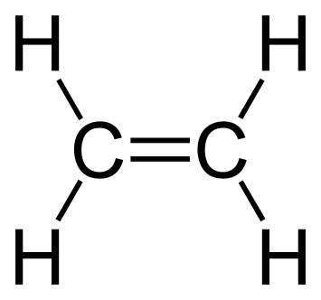

Alkyne series: are organic molecules that have at least one triple bond.
Example: Propyne.

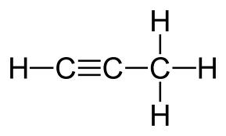

Prefixes are often used in organic naming to indicate the number of carbons on the longest consecutive carbon chain (parent chain).
You will need to know the following prefixes:
Meth: 1 carbon
Eth: 2 carbons
Prop: 3 carbons
But: 4 carbons
Pent: 5 carbons
Hex: 6 carbons
What would be a picture of Butane?

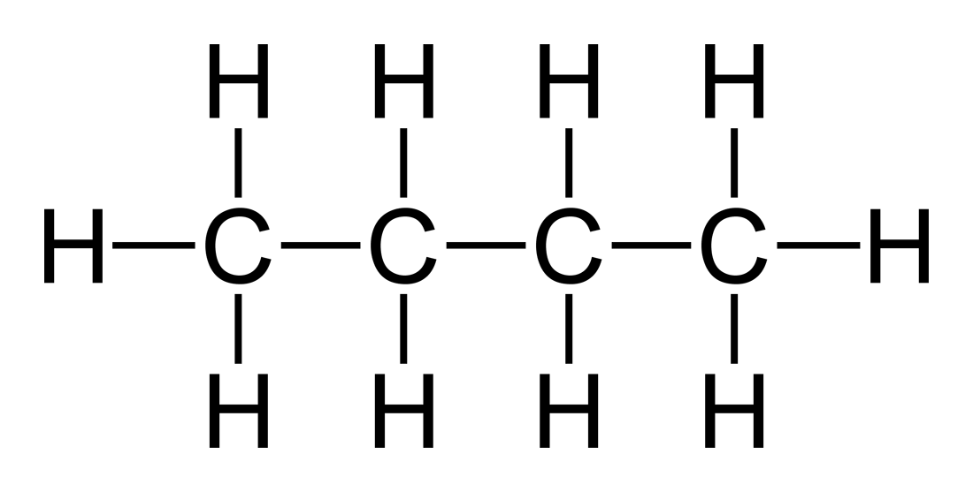

What would be a picture of Butene?

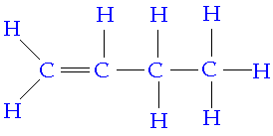
What would be Hexyne?

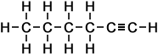

Draw a picture of the following:
- Ethane
- Propene
- Pentyne
- Propane
- Hexane
- Methane

Isomers
Isomers: are different forms of organic compounds that have different properties because they have a different structure (shaped different).
Example:
C₅H₁₂
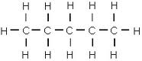
Pentane (Straight Chain)
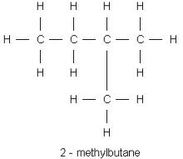
2-Methyl Butane (Bent Chain)

Use the following steps when naming isomers:
- Identify the longest carbon to carbon chain (parent chain) and figure out the ending (ane, ene or yne).
Example:

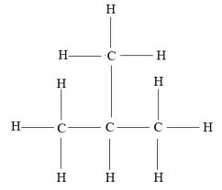
??-?? Propane

- Number the carbons in the parent chain and identify the daughter chain (then work back
words).

2 – Methyl Propane

From the 2nd C. Daughter Chain Parent chain

Draw the following:
- Pentyne
- 3 – Ethyll Hexane
- 1, 4 Di Methyl Hexane
- Butene
- 2 – Propyl Hexane

Cyclo – Isomer and
Benzene
“Cyclo”: Prefix that means circular. If you see the name of an isomer with “Cyclo” in front it means that these are chains that make rings.
H H
H H
Example:
C₅H₁₀
H H
C
H H
C
C
H H
H H

C
C
H H
H H
H H
H H

Cyclo Pentane

C₅H₁₀

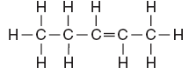
Pentene

Benzene: is a very common Cyclo isomer made of 6 carbons and alternating single and double bonds.
C₆H₆

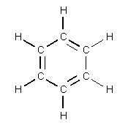
Benzene

**Since benzene is a very common Carbon chain there is a picture that is shorter than the original.

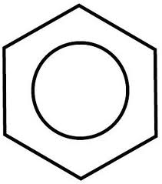
Benzene

Cl

2 – Chloro Benzene
When naming benzene chains you number the carbons by starting at the top and going clockwise. The daughter chains off of benzenes can be smaller carbon chains or single elements.
Example:
Br
Cl

3, 6 – Chloro Bromo Benzene

H
H
H
H
H
C
C
2 – Methyl Benzene

Draw the following:
- Propyne
- Cyclo Butene
- 1,3 - Ethyll Pentane
- 3 – Butyl Benzene
- 1, 2, 6 – Tri Methyl Benzene
- Ethyne

