K_{a} and pK_{a}
Values fro K_{a} and pK_{a} (-log K_{a}) for some typical weak acids and 1 strong are:
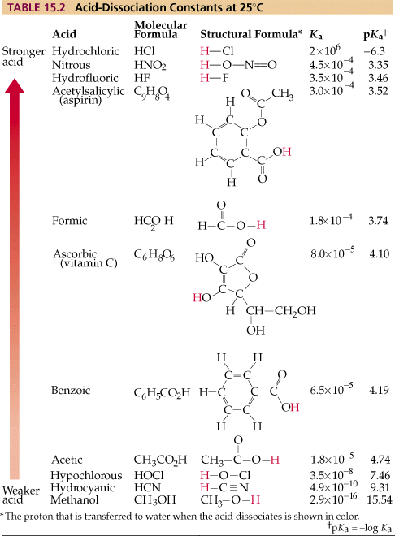
Note that pKa decreases as Ka increases. As indicated in the equilibrium equation (previous notes), the larger the value of Ka, the stronger the acid.
Thus, methanol (Ka = 2.9 x 10⁻¹⁶, pka = 15.54)is the weakest acid listed on the given table.
Nitrous acid (Ka = 4.5 x 10⁻⁴, pKa = 3.35) is the strongest of the weak acids.
Strong acids, such as HCl, have Ka values that are much greater than 1 and pKa values that are negative.

