Isomers
Isomers: are different forms of organic compounds that have different properties because they have a different structure (shaped different).
Example:
C₅H₁₂ C₅H₁₂
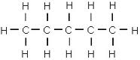
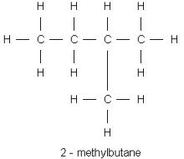

Pentane 2-Methyl Butane
Straight chain Bent chain
Use the following steps when naming isomers:
- Identify the longest carbon to carbon chain (parent chain) and figure out the ending (ane, ene or yne).
Example:

- Number the carbons in the parent chain and identify the daughter chain (then work back
words).

2 – Methyl Propane

From the 2nd C. Daughter Chain Parent chain

Draw the following:
- Pentyne
- 3 – Ethyll Hexane
- 1, 4 Di Methyl Hexane
- Butene
- 2 – Propyl Hexane

