Hydrated Protons and Hydronium Ions
The transfer of the proton is important for both the Arrhenius and the Bronsted – Lowry definitions of an acid.
HA (aq) H⁺ (aq) + A⁻ (aq)
As a bare proton, the positively charged H+ ion is too reactive to exist in an aqueous solution.
Because of it’s reactivity the H+ ion bonds to the oxygen atom of a solvent water molecule to give the trigonal pyramidal hydronium ion H₃O⁺ .
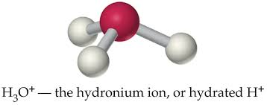

The H3O + ion, which can be regarded as the simplest hydrate of the Proton H(H₂O) ⁺ , can associate through hydrogen bonding with additional water molecules, to give higher hydrates with the general formula H(H₂O)_{n} ⁺ (n = 2,3 or 4).
Examples: H₅O₂⁺, H₇O₃⁺ and H₉O₄⁺.
It’s likely that aqueous acidic solutions contain a distribution of H(H₂O)_{n} ⁺ ions having different values of n (subscript outside the oxygen).
The abbreviations H+ (aq) and H3O+ (aq) can be used to mean the same thing:
A proton hydrated by an unspecified number of water molecules.

