Fission and Fusion
Nuclear fusion is the reaction in which two or more nuclei combine together to form a new element with higher atomic number (more protons in the nucleus).
The energy released in fusion is related to E = mc ² (Einstein’s famous energy-mass equation). On earth, the most likely fusion reaction is Deuterium–Tritium reaction.
Deuterium and Tritium are both isotopes of hydrogen.
Nuclear fission is the splitting of a massive nucleus into photons in the form of gamma rays, free neutrons, and other subatomic particles.

Fission
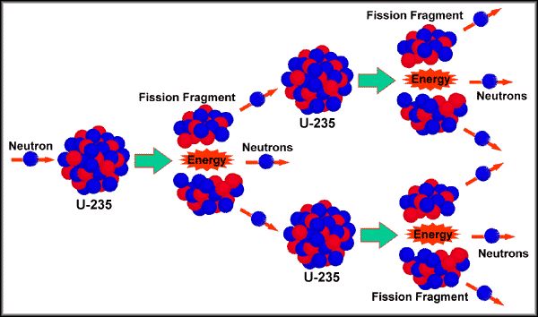
Both fission and fusion nuclear reactions are chain reactions.
A nuclear chain reaction occurs when one nuclear reaction causes an average of one or more nuclear reactions, which happens very rapidly giving off a huge amount of energy.

