Faraday’s Law
F. Law: The amount of voltage that is produced by a coil of wire and a magnet is directly proportional to the number of loops that are in the coil and the rate at which the coil is spinning.
Example:
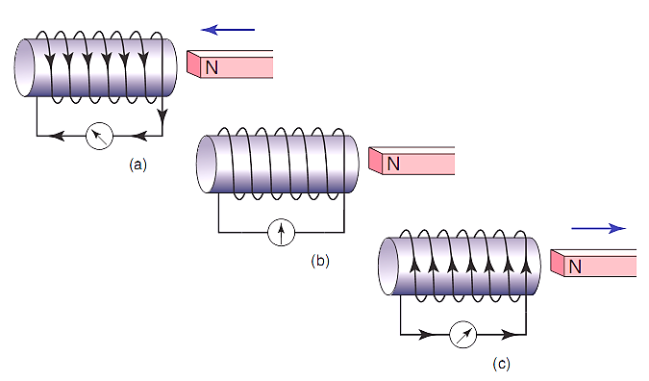
Which Example will produce the most voltage??
C. More movement.

