Expansion of Water
Most types of matter will always expand when it is heated.
Water is different because it contracts when it changes temperature from 0 C (solid) to 4 C (Liquid).
One of the reasons that this occurs is because of the unique shape of the ice crystals.
Since ice forms a Hexagon shape when water freezes it is less dense than liquid water that is at 4 C.

Example:
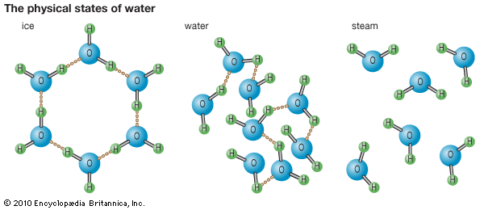

Ice Water @ 4 C Steam.

**This is why ice floats in water.

