Electrolysis
Learning Target:
The students will learn what electrolysis is and how to use it to compare how well electricity is running (called conductivity) through different solutions.
Electrolysis:
Happens when electricity is ran through water. A chemical reaction occurs that breaks the bond between the Hydrogen and Oxygen and turning them into gases.
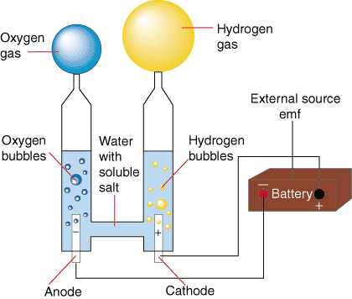

**Some solutions react with electricity at a faster rate (faster bubbles). If the reaction is happening faster the solution is conducting electricity better.

