Electro Magnets
Elec. Magnet: can be created by running an electric current through certain metals (Iron, Copper, Steel and a few others.
The strength of the magnet depends on the number of “coils” and the size of the current running through the conductor around the magnet.
Example:
Weak electromagnet (less coils)
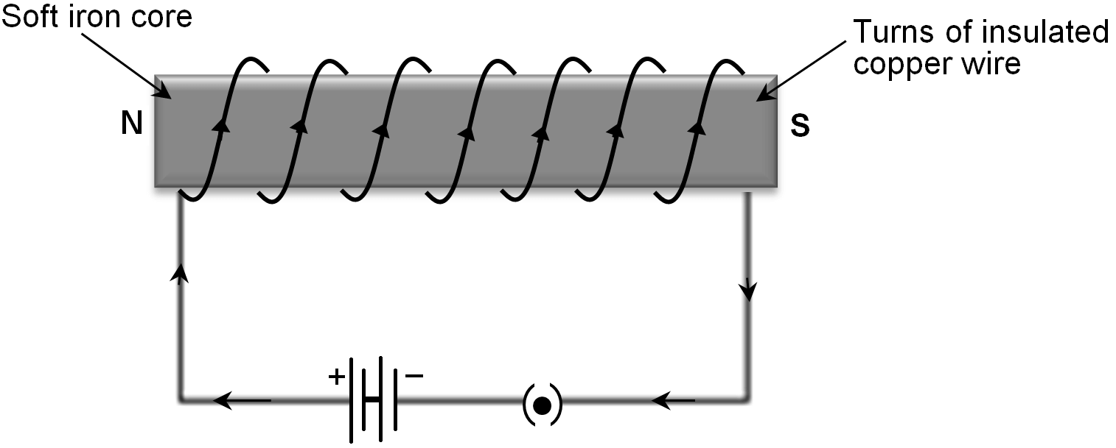

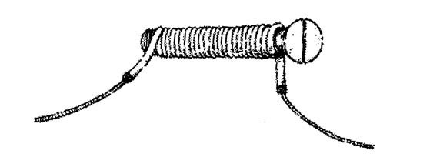

Stronger magnet (more coils).

