Direction of Acid – Base reactions
I
Using the charges of the solutions and table 15.1:
- Identify the acids and bases.
- Give the direction of the reaction.
HCO₃⁻ (aq) + SO₄²⁻ (aq) HSO₄(aq) ⁻ + CO₃(aq) ²⁻
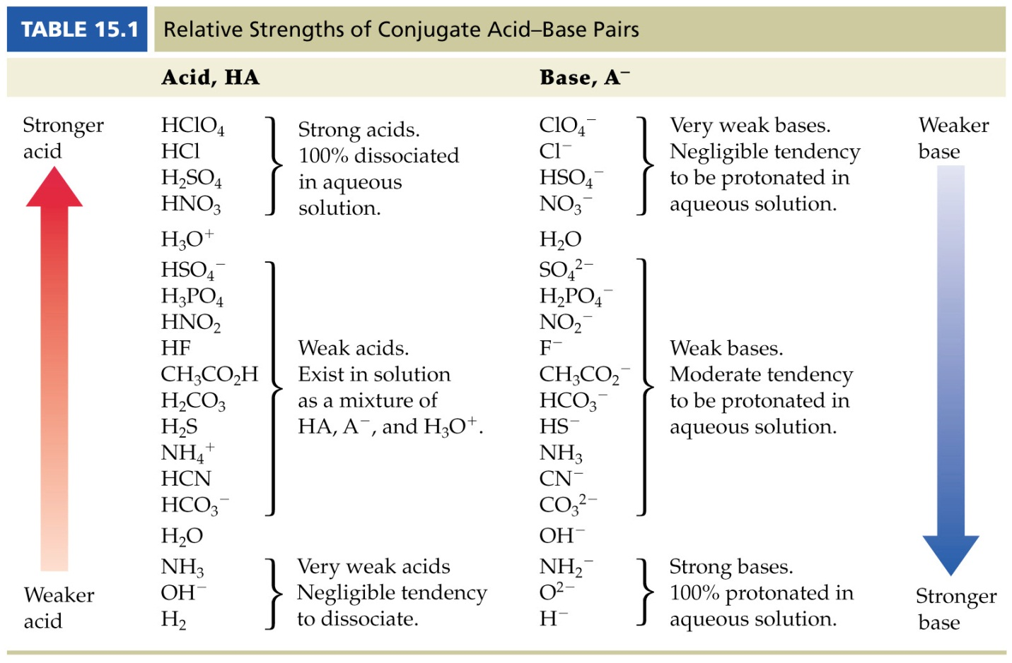

Using the charges we know that HCO₃⁻ and HSO₄⁻ are the acids and SO₄²⁻ and CO₃²⁻ are the bases.
The given table indicates that HSO₄⁻ is the stronger acid and CO₃²⁻ is the stronger base.
Therefore, CO₃²⁻ gets the proton and the reaction proceeds from Right to left.
HCO₃⁻ (aq) + SO₄²⁻ (aq) HSO₄⁻ (aq) + CO₃²⁻(aq)
Weaker acid Weaker base Stronger acid Stronger base

