Cyclo – Isomer and
Benzene
“Cyclo”: Prefix that means circular. If you see the name of an isomer with “Cyclo” in front it means that these are chains that make rings.
Example:
H H
H H
C₅H₁₀
H H
C
H H
C
C
H H
H H

C
C
H H
H H
H H
H H

Cyclo Pentane

C₅H₁₀

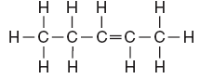
Pentene

Benzene: is a very common Cyclo isomer made of 6 carbons and alternating single and double bonds.

C₆H₆

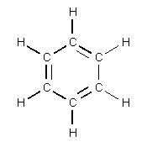
Benzene

**Since benzene is a very common Carbon chain there is a picture that is shorter than the original.

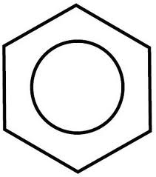Benzene

Cl

2 – Chloro Benzene
When naming benzene chains you number the carbons by starting at the top and going clockwise. The daughter chains off of benzenes can be smaller carbon chains or single elements.

Example:
Br
Cl

3, 6 – Chloro Bromo Benzene

H
H
H
H
H
C
C
2 – Ethyll Benzene

Draw the following:
- Propyne
- Cyclo Butene
- 1,3 - Di Ethyll Pentane
- 3 – Butyl Benzene
- 1, 2, 6 – Tri Methyl Benzene
- Ethyne

