Chemical Equilibrium
Chemical Equilibrium: the state reached when the concentrations of reactants and products remain constant over time.
Equilibrium constant (K_{c}): is a number unique to a specific reaction that depends on the concentration of the products, concentration of the reactants and the coefficients in the chemical equation.
Example:
aA + bB cC + dD
Kc = [C]^{c}[D]^{d}
[A]ª[B]^{b}
[C]= concentration of product C. c = product C’s coeffiecient.
[D] = Concentration of product “D”. d = Product D’s coeeficient.
[A] = Concentration of reactant A. a = A’s Coefficient.
[B] = Concentration of reactant B. b = B’s coefficient.
Using a given table the equilibrium constant can be found along with a balanced chemical equation.
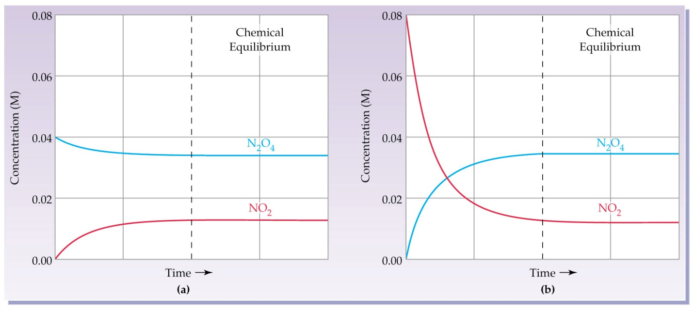
According to graph a the concentration of N₂O₄ at equilibrium is .0337 M/L and the concentration of the NO₂ is .0125 M/L.
Example: Using the equation ant the given table what is the equilibrium constant for the decomposition of N₂O₄ (g)?
N₂O₄ (g) 2NO₂

Kc = [NO₂]² / [N₂O₄] = (.0125)₂ / .0337) =
4.64 x 10⁻³

