Calculating pH II
Since pH is based on negative logs, Scientific Notation and significant digits are often used.
Example: 2.5 x 10⁻³ M HCl pH?
-log (2.5 x 10⁻³) = 2.60206
2.6 (sig. digits).
To appreciate the extent to which the pH scale is a compression of the [H3O+] scale, compare the amounts of 12 M HCl required to change the pH of the water in a swimming pool:
100 ml of 12 M HCl is needed to change the pH from 7 to 6.
10,000 L truckload of 12 M HCl is needed to change the pH from 7 to 1.
The pH scale and values for some common substances are:
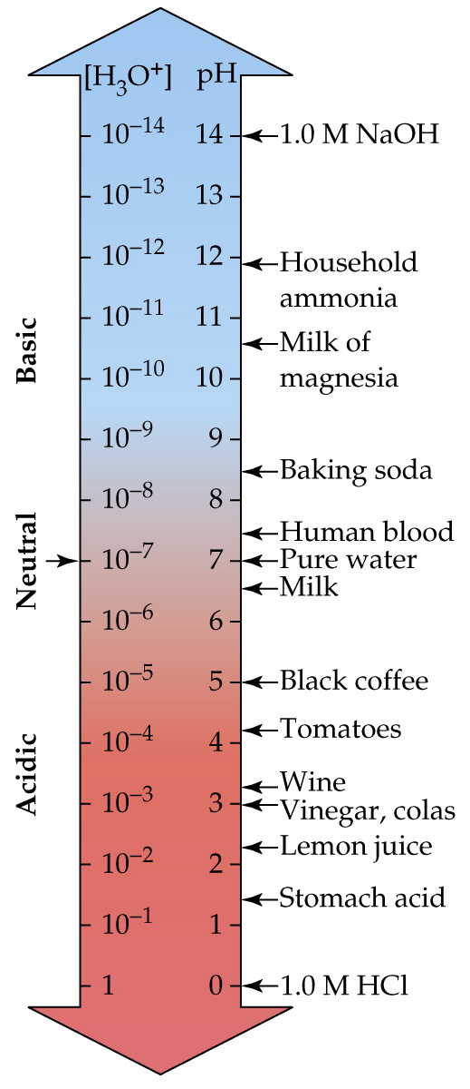
Because the pH is the negative log of [H3O+], the pH decreases as [H3O+] increases.
Thus, when [H3O+] increases from 10⁻⁷ to 10⁻⁶, the pH decreases from 7 to 6.

