Black Hole Orbiting each other article

Revolutionary discovery: Scientists find gravitational waves Einstein predicted

For the first time ever, scientists have directly detected gravitational waves, bizarre ripples in space-time foreseen by Einstein a century ago. The discovery was the final, acid test of Einstein’s general theory of relativity.

Einstein has been proven right – again.
For the first time ever, scientists have directly detected gravitational waves, bizarre ripples in space-time foreseen by Einstein a century ago. The discovery was the final, acid test of Einstein’s celebrated general theory of relativity, and once again Einstein’s genius held up to scrutiny.
“Einstein comes out with beaming success,” Caltech’s Kip Thorne, one of the founders of the observatory that caught the gravitational waves, told reporters Thursday.
The find not only validates one of the most fundamental theories in physics but also promises to revolutionize astronomy. Because gravitational waves carry information about their source, the ability to detect these weird undulations will allow researchers to study distant and elusive features of the universe.
Study of the universe via gravitational waves “will be the astronomy of the 21st century,” predicts Arizona State University’s Lawrence Krauss, who is not part of the discovery team. “This is a whole new window on the universe.”
The waves in question arose during the close approach of two black holes some 1.3 billion years ago, when multicellular life began to spread on Earth. Traveling at the speed of light, the waves reached our planet in September -- precisely when a observatory built to detect them was emerging from a long hiatus.
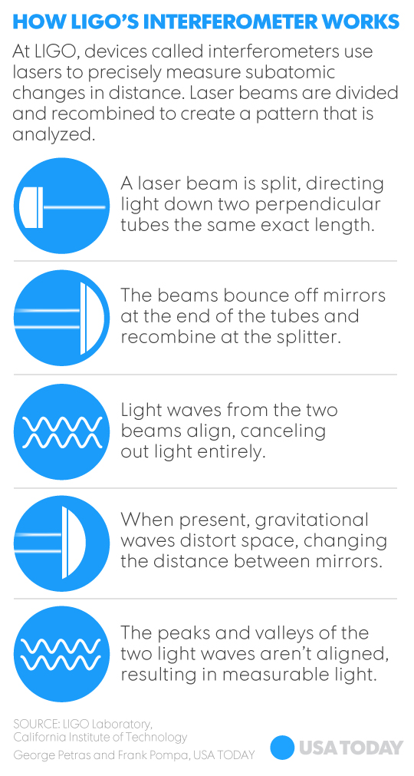
When scientists first saw the data suggesting that they’d captured a gravitational wave, they thought the results seemed to good to be true. Past claims of gravitational waves have proven unreliable, and there are many possible sources of error.
But months of analysis persuaded the researchers that this is the genuine article. A coincidence that could produce a false alarm of this magnitude occurs only once every 200,000 years, said Louisiana State University’s Gabriela Gonzalez, a spokesperson for the scientific coalition that made the discovery, so “we are very, very confident this is real.”
The discovery was published Thursday in Physical Review Letters, in a paper with more than a thousand authors. The results confirm that gravitational energy can actually deform matter and time, and they also confirm the existence of black-hole pairs that are circling round each other.
The find is a triumph for the Laser Interferometer Gravitational-wave Observatory, the mammoth observatory, some 40 years and $1 billion in the making, that picked up the waves’ stealthy advance. Each of LIGO’s twin outposts – one in Hanford, Wash., one in Livingston, La. -- consists of an L-shaped tunnel, the arm of each L stretching 2-1/2 miles.
When a gravitational wave hits, the length of the arms changes ever so slightly. The detectors are sensitive enough to pick up a length change of only one ten-thousandth the diameter of a proton, which is one of the particles making up an atom.
The gravitational waves detected by LIGO came from the final moments before the collision of two black holes somewhere in the Southern Hemisphere. The two had been spiraling closer and closer toward each other for billions of years, spitting out gravitational waves as they approached.
In the last, cataclysmic instant before they crashed together and merged into one, they generated waves with more energy than the entire visible universe. The waves rippled outward at the speed of light, eventually arriving at – and passing through -- Earth.
Many such cosmic spectacles have been invisible to science until now. “We’re missing some of the most violent, dynamic and exciting things in the universe,” says the University of Maryland’s Cole Miller, but gravitational waves are “going to give us a remarkable view into a universe that has largely been denied us.”
Scientists have never gotten a peep at the very edge of a black hole, for instance. But studying gravitational waves, which are born at that edge, will “allow us to see almost into the heart of a black hole,” Krauss says. The waves will allow researchers to probe “realms we’ve only thought about, realms of science-fiction movies.”
Researchers had long worried that the first sign of gravitational waves would be ambiguous or fuzzy. Instead “the data are spectacular,” says Scott Ransom of theNational Radio Astronomy Observatory, adding that the data prompted one of his colleagues to shed tears of happiness.
Assuming the detection is confirmed, Miller says, his reaction is “unalloyed joy. … This is fantastic.”
The discovery wouldn't have happened at all if LIGO co-founder Rainer Weiss of MIT had had his way. On a visit to the observatory's Louisiana outpost four days before the detection, Weiss found a technological flaw he wanted to fix. The repair would've taken a week, and his colleagues were reluctant to wait that long. "Thank God … that I listened to them," Weiss says in retrospect. "Otherwise the event would not have registered."
When the momentous data came through, "it was almost too good to believe. It was like, 'Is this a drill?' " said LIGO science team member Neil Cornish of Montana State University. After sitting on the discovery for months, he'll be celebrating tonight with French champagne.
Gravitational waves confirmed
Astrophysicists have announced the discovery of gravitational waves, ripples that travel at the speed of light through the fabric of space-time. A 1916 theory of Albert Einstein’s predicted their existence.
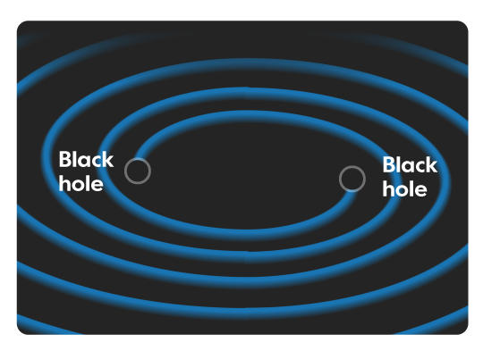
The ripples can be unleashed by movements of massive objects in space, such as a spinning neutron star or a pair of black holes orbiting each other.
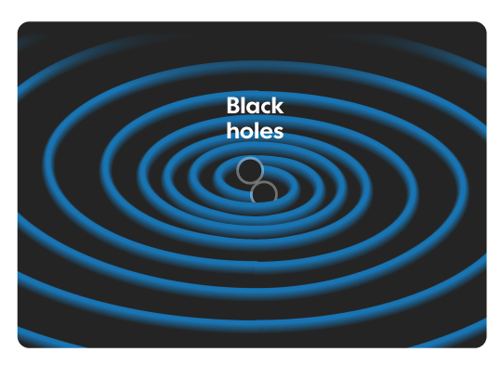
Two black holes swinging around each other create gravitational waves as they spiral closer together.

Not for the first time, the world of physics is abuzz with rumours that gravitational waves have been detected by scientists in the US. Lawrence Krauss, a cosmologist at Arizona State university, tweeted that he had received independent confirmation. USA TODAY
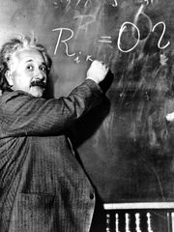
Albert Einstein writes out an equation for the density of the Milky Way on the blackboard at the Carnegie Institute, Mt. Wilson Observatory headquarters in Pasadena, Calif., on Jan. 14, 1931. (Photo: Associated Press)
9065CONNECTTWEET 249LINKEDIN 125COMMENTEMAIL

